

United to Reform:

Benefits Management Framework

# Foreword

I am pleased to introduce this benefits management framework for UN reform. The framework is intended to help us know we are delivering the reforms we promised; (a) improving our ability to deliver mandates more effectively, and (b) demonstrating the UN is a more transparent, accountable, agile and flexible organisation. Furthermore, the framework is the stepping stone for the UN to transition to a continuous improvement system.

Benefits are defined as, “…*the measurable improvement resulting from an outcome perceived as an advantage by one or more stakeholders, which contributes towards one or more organisational objectives*…”.[1]. There are many types of benefits, and it is important to recognise that in a reform programme focussed on improving how we work benefits may not be financial or even quantifiable, but this does not mean they are not real improvements.

Improvement doesn’t happen by accident. When planning and delivering reforms we need to consider:

* **What are we trying to achieve and why?**Is there a gap or a problem we need to fix, or an obvious opportunity to improve how we deliver our mandates?
* **How do we know that we need to make a change?** Do we have a good baseline of current performance or do we need to establish one?
* **If we made the change, what would be the benefit?**What would be improved, by how much, and when? How confident are we in this assessment?
* **How will we know we have realised the benefits?**Do we have the required performance measurement systems in place, and how fast can we develop them if not?Who would sign off that the benefits have been achieved?

This thought process is the basis of benefits management. Ideally, we should be answering these questions before we start each reform initiative. However, it is never too late to apply the tools and techniques contained duringimplementation of reform initiatives**.**

Benefits management is not a ‘tick box exercise’. UN staff need to apply critical thinking and professional judgement supported, but not constrained by, the approaches and tools detailed in this framework. This framework is principles based and reflects lessons learned from our collective experience to date, the results of a recent pilot, and good practice from other organisations around the world. The framework is a live document and will be continuously improved based on our experiences.

Finally, there is an expression; “*every improvement is a change, but not every change is an improvement*”. It is our responsibility to help the Secretary-General demonstrate to the UN’s stakeholders that the UN is not only changing but improving. Proving the benefits throughout the reform process and beyond will help us achieve this.

*Jens Wandel*

*Special Advisor to the Secretary-General on Reforms*

# Contents

Foreword 2

Contents 3

Introduction 5

Scope of the framework 5

How to use the framework 6

Figure 1: The benefits management system 7

Understanding your starting point 7

Part 1: Introducing benefits management 9

What are benefits? 9

Defining the outputs, outcomes and benefits of reform 10

Figure 2: Outputs, Outcomes and benefits 10

What is benefits management? 11

Figure 3: Guiding principles of benefits management across the project lifecycle 12

Benefits management and UN reform 12

Figure 4: Benefits management and UN Reform 13

Part 2: The benefits management cycle 14

Figure 5: The Benefits management cycle 14

1. Identify 15

Identifying potential opportunities to improve 15

Identifying and prioritising reform projects to work on 16

Seven steps to identifying the benefits of reforms 16

1) Purpose and rationale 17

2) Alignment with the strategic objectives of UN reform 17

3) Benefits categories 17

4) Predicted level and type of benefits 17

5) Estimated ease of implementation 18

6) Prioritising projects 18

7) Agreeing ownership 18

2. Plan 19

Producing a benefits statement 19

Figure 6: An example Gantt chart 24

Baselining performance 24

3. Track 26

Tracking at project level 26

Enabling tracking at portfolio level 27

4. Realise 27

Realising benefits 27

Assurance over benefits realisation 28

What if there are dis-benefits 28

5. Confirm 29

Confirming benefits 29

Confirming benefits to Portfolio level 29

Evaluating benefits 29

Part 3: Benefits management at portfolio level 31

Figure 7: The Benefits management enablers at Portfolio level 31

Ownership 32

Approach 32

Governance 32

Track 33

Figure 9 Screenshot of the Benefits Tracking Register 34

Realise 34

Confirm 34

Annex A: Benefits Tracking Process 35

# Introduction

1. The goal of the Secretary-General’s reforms is a 21st-century UN focused more on people and less on process, more on delivery and less on bureaucracy. The true test of reform will be measured in tangible results in the lives of the people the UN serves – and the trust of those who support our work. **However, this framework is focussed on understanding the benefits of reform; i.e. are we implementing changes that improve the UN’s effectiveness.** It is not designed to demonstrate if the UN is achieving its overall outcomes, for example progress on the Sustainable Development Goals or achieving Peace & Security in a given country or region – that is the role of existing organisational performance measurement systems.
2. Benefits management is fundamental to establishing trust, and is an area where trust can, and in the other UN reform programmes has, eroded very quickly. The UN has struggled to prove the benefits of past reforms to its stakeholders, and therefore the governing bodies are insisting a clear focus on the benefits of reform is built into the Secretary-General’s plans from the outset. For example, in 2018 the ACABQ wrote, “…*As in the case of other major reform initiatives, and as repeatedly recommended by the Board of Auditors and requested by the General Assembly, the Committee emphasizes the need to establish at the start of the process the expected benefits and baseline information, the methods for monitoring, measuring and reporting on progress, and plans for the realization of benefits*…”.

## Scope of the framework

1. This framework is intended to help UN staff respond to the concerns of the General Assembly, the ACABQ and the oversight bodies by ensuring benefits management thinking is at the heart of the reform programme. By implementing this framework, we will:

* Demonstrate a direct link between the overall strategic objectives of reform and the rationale and benefits of individual reform projects;
* Enable an iterative approach to identify, track and realise benefits from reforms; and
* Establish a benefits management system in the UN for this and future initiatives.

1. The framework is designed to help us understand when the Secretary-General’s reforms have delivered benefits; i.e. that there has been an improvement in the UN’s accountability, transparency and ability to deliver mandates. Proving if reform has had a positive effect on performance is reliant on mature organisational performance measurement systems being in place and operating effectively. Oversight bodies have concluded that much of the UN does not consistently have such systems, and consequently this is an area the Secretary-General’s management reform pillar is focussed on improving through improved use of management information through applying data analytics, management dashboards and central monitoring capabilities.
2. The benefits management system described in this framework will help us understand which reform projects are having a positive effect, what that effect is, and how we know this is true. This is key to Continuous Improvement, as we have a basis to decide which ‘experiments’ should be reproduced in other parts of the organisation, or if we need to change our approach. Where existing performance measurement systems are not up to the task, teams will need to undertake discrete baselining and tracking exercises to generate required information.

## How to use the framework

1. Benefits management is part art and science. It is not a ‘tick box exercise’ and UN staff need to apply critical thinking and professional judgement supported, but not constrained by, the approaches and tools detailed in this framework. This framework contains guidance on building a benefits management system at all levels of United Nations reform. **Figure 1** illustrates how the framework is structured:

* **Part One** introduces the purpose, concepts and principles of benefits management;
* **Part Two** contains guidance on benefits management at **project level** across the five stages of the end to end benefits management cycle (*Identify, Plan, Track, Realise & Report, and Confirm*); and
* **Part Three** contains guidance on establishing **portfolio** level enablers for the UN’s benefits management system.

1. Each part of this framework contains hyperlinks to templates or suggested methodologies to help you build a benefits management system in your part of the UN. The framework is designed to be used as a standalone approach, or to complement existing project management methodologies.
2. For the purposes of this framework, ‘**Portfolio level**’ refers to the benefits management activities which need to be in place at four distinct but interrelated levels (**Figure 2**):

* United to Reform – overall benefits of the Secretary-General’s reforms, owned by EOSG;
* Pillar – the benefits delivered under the three reform pillars;
* Entity – the benefits delivered improving each Department, Office, Mission etc; and
* Process or Policy – the benefits delivered improving each common process or policy.

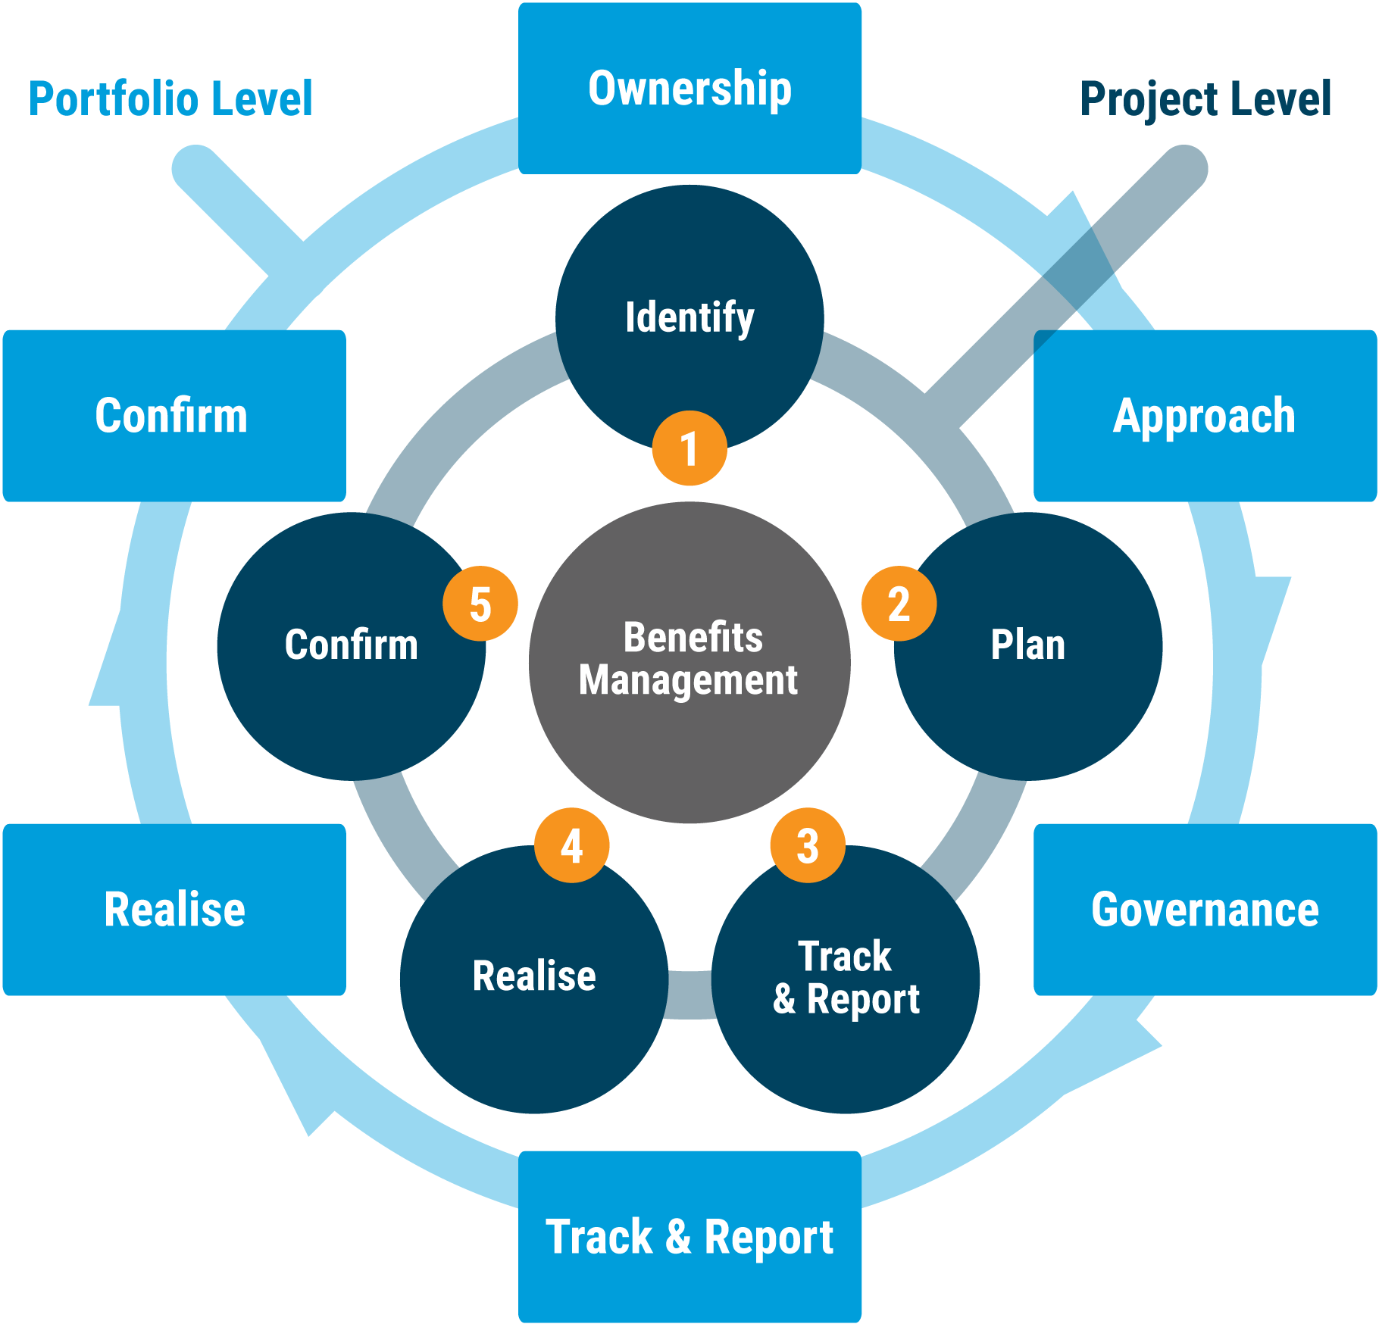**NB Benefits to the United Nations will mainly be realized by entities implementing the reforms. However, benefits accruing to governments and other UN stakeholders should be captured and validated wherever possible.**

Figure 1: The benefits management system

Source: United to Reform

## Understanding your starting point

1. The key to getting value from this framework is to understand your starting point:

* Do you have a reform plan at project / programme / portfolio level?
* Do your portfolio level reforms have an existing, quantified benefits plan?
* Do you have an approved reform project, are you already implementing, or are you still in the process of developing the business case?
* Do you have an existing project management approach which requires the detailed quantification of benefits as part of the business case and approval process?
* Do you have a strong organisational performance measurement system in place and operating from which improvements can be readily identified, tracked and proven?
* Do you have an existing benefits management approach including method, training, assurance, responsibility for benefits management?

Dependent on your answers to these questions, although all parts will be useful, different parts of this framework will be more relevant to your situation than others.

# Part 1: Introducing benefits management

This section introduces what benefits management is and its importance to UN reform.

***Key learning:*** *Delivering**benefits is the reason we undertake reform – and we want to demonstrate to our stakeholders we have improved how we work and are on a positive direction of travel. Improvements do not happen by accident. As such, benefits need to be managed and managed with the same care and attention as milestones, costs or risks.*

## What are benefits?

1. Benefits are defined as,

“…*the measurable improvement resulting from an outcome perceived as an advantage by one or more stakeholders, which contributes towards one or more organisational objectives*…”.[2]

1. The realisation of benefits demonstrates that reform has been worthwhile, and the investment of time, money and resources have had a positive impact for stakeholders. It is worth considering the different elements of this definition, and if you think your organisation has in place the ‘requirements’ for effective benefits management:

***Measurable improvement******:*** requires a clear understanding of business performance before and after a change has been introduced. Performance can be judged using a balanced set of metrics which track, for example, quality, delivery, cost, people, safety and environmental performance.

***An outcome:***requires a targeted intervention to achieve a prescribed result in how or what is delivered.

***Perceived as an advantage by stakeholders:*** requires a clear understanding of who stakeholders are, what they value, and if they are satisfied.

***Contributes to organisational objectives:*** requires a ‘golden thread’ between organisational objectives and the benefits targeted by a reform initiative.

1. If your entity does not have any or all the above requirements, benefits management in your reform activities may require more time and effort, particularly at the identification and planning stages.

### Defining the outputs, outcomes and benefits of reform

1. 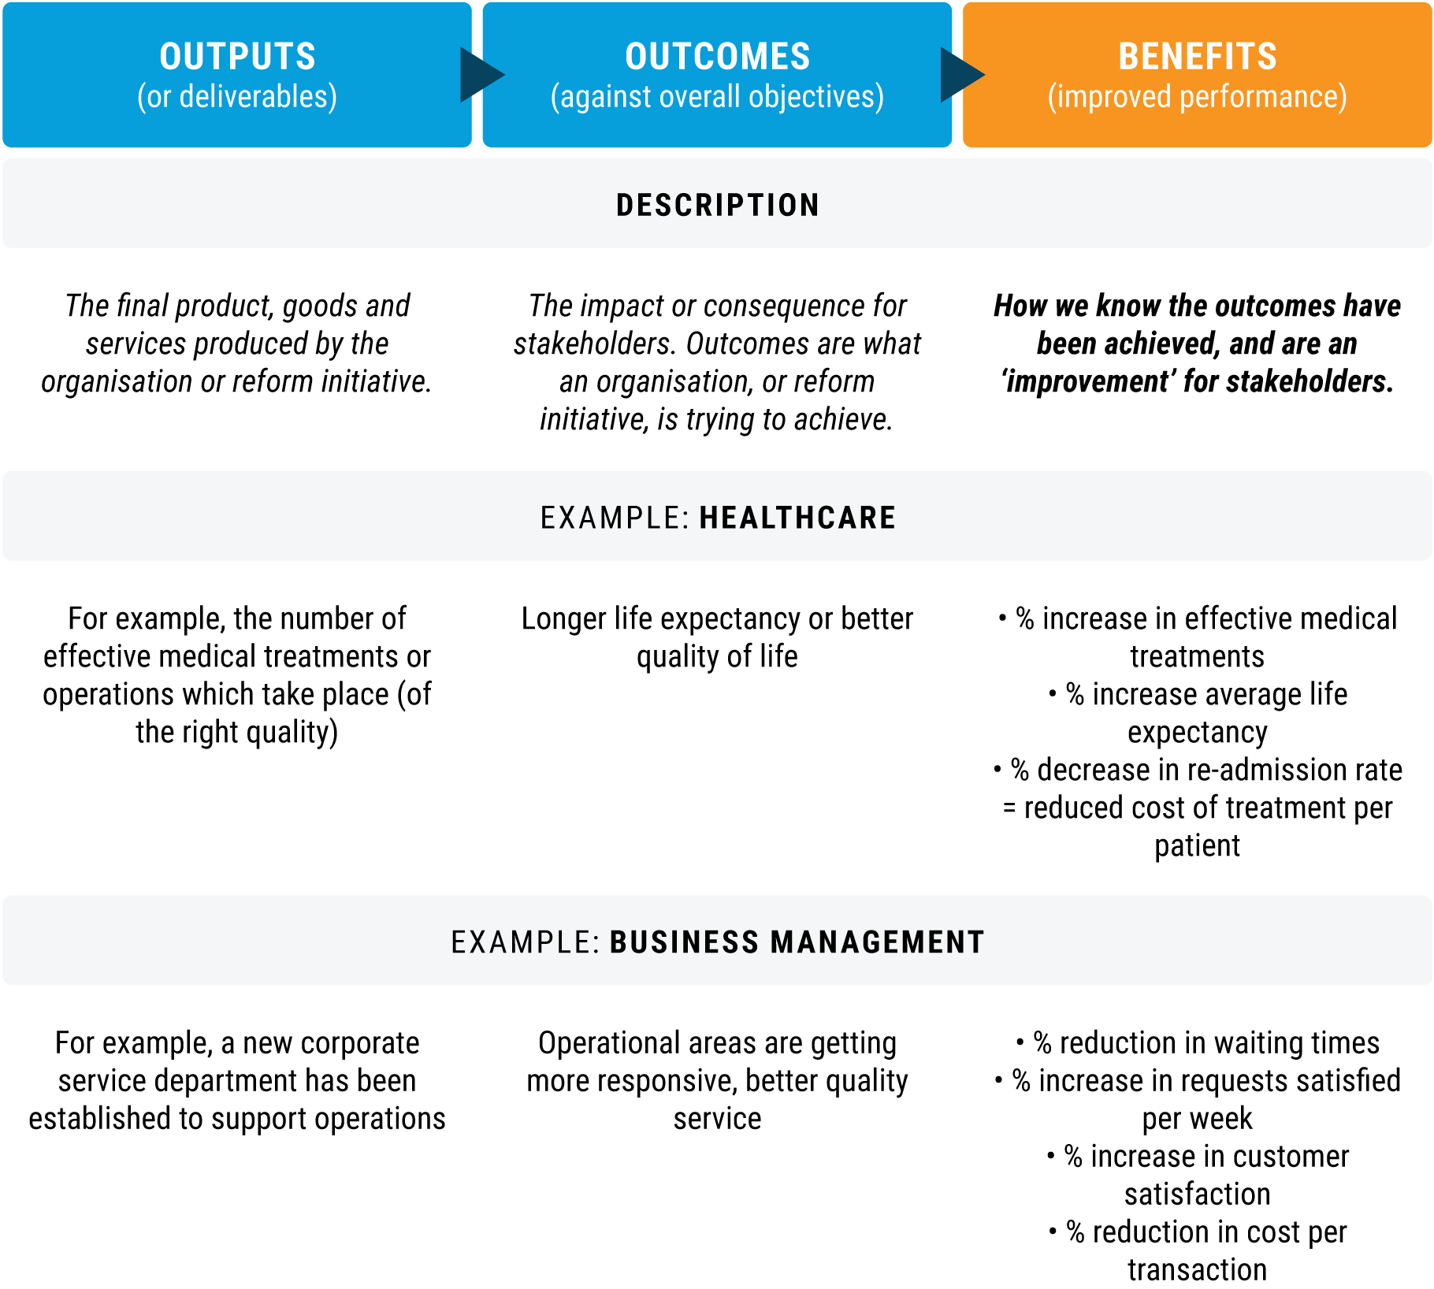Defining benefits as opposed to an output or an outcome is an important and sometimes iterative process when planning and delivering a reform project. A common mistake is to identify the output of the project, e.g. implementing a new IT system, as the benefit. The IT system represents an investment. The benefits of a new IT system represent the ‘return on investment’. This does not necessarily need to be financial, for example, it could be improved speed of delivery, increased quality of processing through automation, or improved visibility of organisational performance through more comprehensive management information. **Figure 2** illustrates the relationship between outputs, outcomes and the benefits of reform. Benefits are how we know the outcomes have been achieved, and what the improvement is for stakeholders.

Figure 2: Outputs, Outcomes and benefits

Source: United to Reform

## What is benefits management?

1. Benefits management is, “…*the identification, definition, planning, tracking and realisation of business benefits…*”.[3] As noted above, benefits are the reason organisations embark on reform, therefore managing benefits needs to be approached with as much care and attention as managing cost or schedule.
2. Effective benefits management should already be an integral part of your organisation’s approach to project management and continuous improvement. The identification of benefits should happen before a project is started, informed by defining a problem, or a change in strategy or policy. Benefits are then developed throughout the project lifecycle and measured during project implementation and stabilization, and after the project has closed. Considering benefits throughout the project lifecycle provides reassurance that the project is still a worthwhile use of resources.
3. **Figure 3** illustrates the 10 key principles of benefits management through the reform project lifecycle.

**Figure 3 Notes**

**1.** Project and benefits management are part of the same project lifecycle.

**2.** ‘As is’ performance should be baselined during **Phase 1 & 2**. Ideas on how to prove benefits can start here and continue through the planning process in **Phase 2**.

**3.** A ‘Target condition’, i.e. the improved level of performance that can be achieved following the reform project should be defined in a detailed benefits statement during the **Phase 2**.

**4.** ‘As is’ performance is the baseline against which benefits are measured.

**5.** Performance can drop during the implementation phase. It is important to keep tracking performance to identify when the benefits realisation phase starts.

**6.** Performance should plateau throughout **Phase 4** - the project stabilisation phase.

**7.** **Phase 4 and 5** is when benefits can be said to be realised with any confidence. The difference between previous ‘as-is’ performance and the current performance, less resources used to implement the project, are the net benefits accrued. This does not necessarily need to be demonstrated as financial benefits, but the cost of implementation cannot be ignored.

**8.** From **Phase 5** onwards we should continuously assess and reconcile current performance with the ‘target condition’ defined in Phase 2.

**9.** **Phase 5** should include an evaluation of the benefits achieved. The evaluation team can be from the entity concerned but should be independent of the reform project or the business areas affected.

**10.** Continuous improvement projects should continue from **Phase 5** onwardsto (a) help embed the results of the reform project by responding to any implementation issues which have arisen, and (b) take advantage of any new opportunities to improve which were unknown prior to implementing the project.

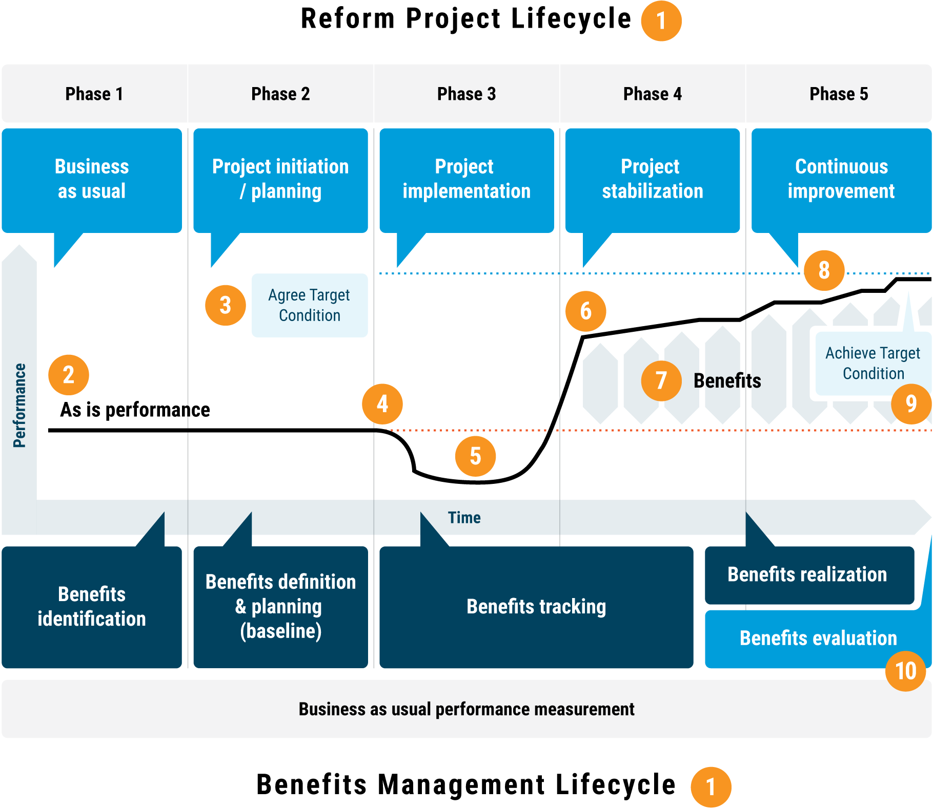Figure 3: Guiding principles of benefits management across the project lifecycle

Source: United to Reform

## Benefits management and UN reform

1. The Secretary General has promised that, “*Over time, full implementation of the reforms is expected to yield a range of benefits, including improved effectiveness of mandate delivery, improved transparency and accountability and enhanced confidence in the ability of the United Nations to deliver on the mandates entrusted to it by Member States*.”[4]
2. In November 2018, the Secretary General informed the General Assembly that “…*we have prepared a benefits management framework and launched a pilot to test the methodology. This approach – the first to be done at this scale and complexity – will ensure that we set baseline information at the outset and measure benefits throughout the implementation process. Member States and other stakeholders will be asked to assess our implementation through interviews and surveys. This will enable us to identify areas where benefits are not being realised and to make the necessary course corrections*...”[5]. A link to the lessons from the benefits management pilot can be found on the [United to Reform website](https://reform.un.org/).
3. Reforms, and the benefits they deliver, need to directly contribute to: (a) the overall strategic vision for UN reform and (b) the individual objectives of the reform pillars. The outcomes and rationale for change are derived directly from the Secretary-General’s reports on management, development and peace and security pillar.
4. 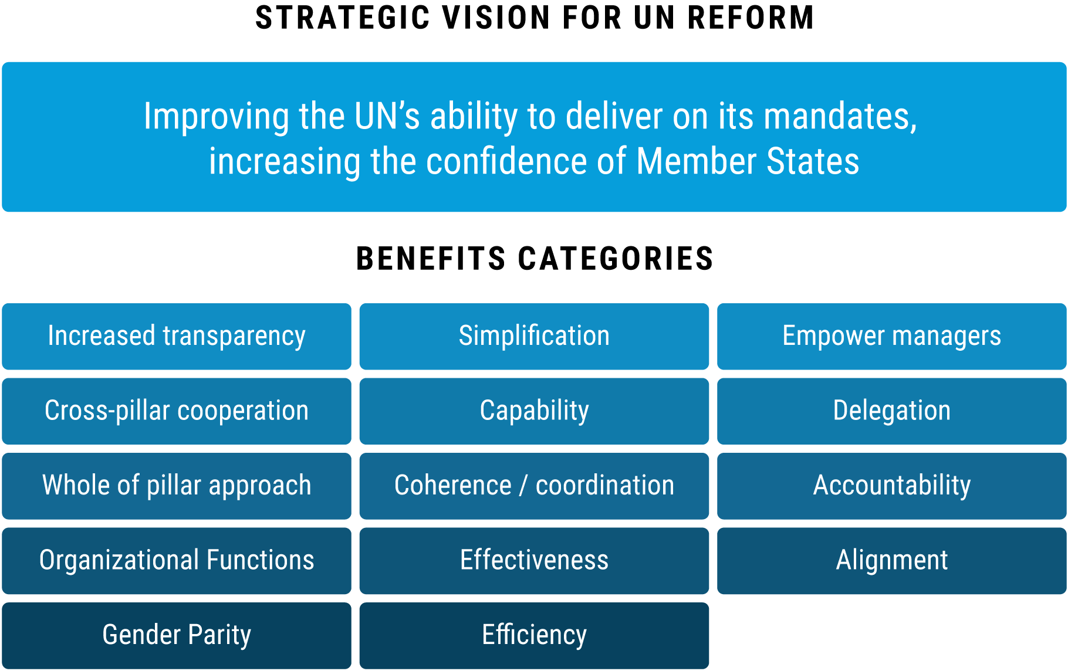**Figure 4** illustrates how the benefits categories established during the United to Reform benefits management pilot link to the overall vision of the Secretary-General’s reforms. Each reform initiative needs to demonstrate how their reform contributes.

Figure 4: Benefits management and UN Reform

Source: United to Reform

# Part 2: The benefits management cycle

This part of the framework guides teams through the end to end benefits management cycle at project level (**Figure 5**).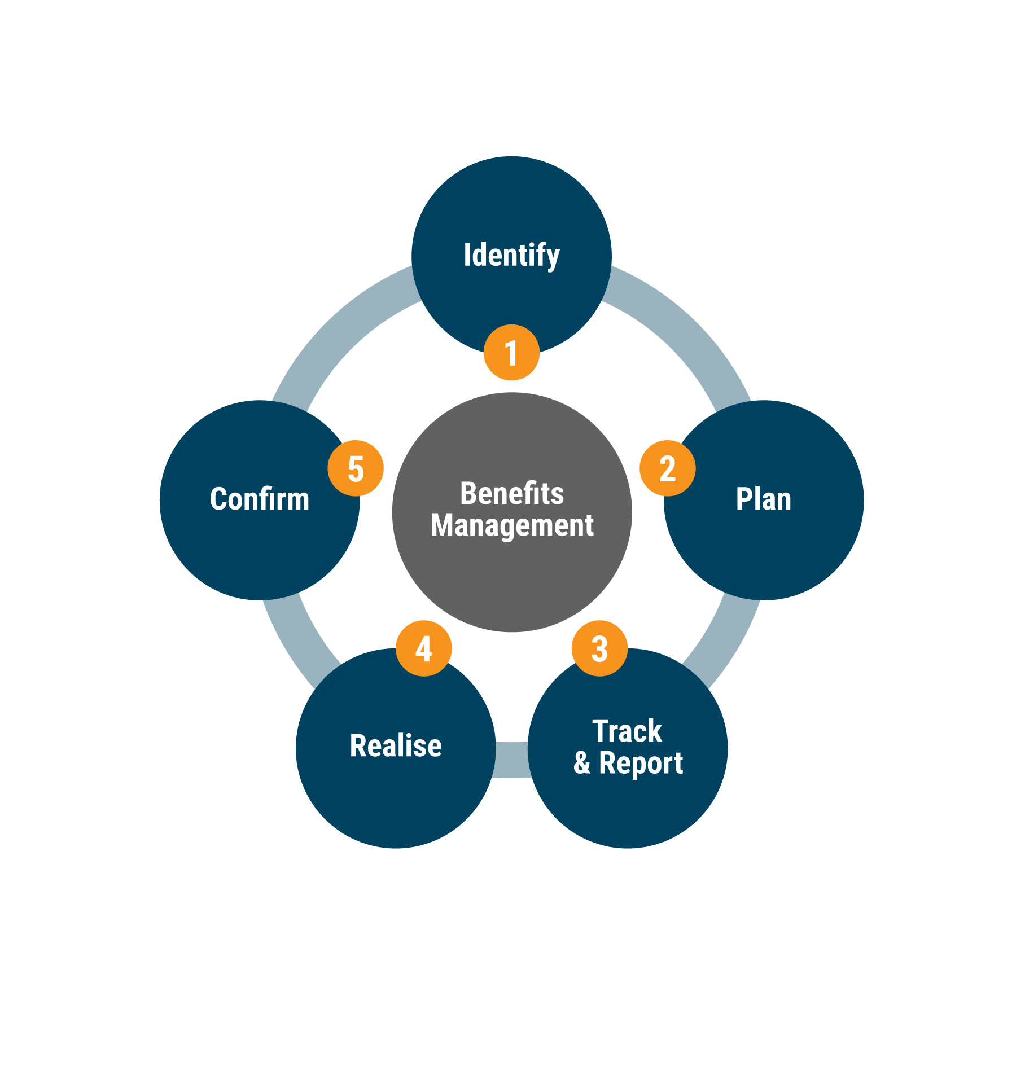

Figure 5: The Benefits management cycle

Includes hyperlinks to the relevant parts of the chapter – hover, hold down ‘ctrl’ and click. Source: United to Reform

## 1. Identify

This section contains guidance on identifying opportunities to improve. The goal is to produce a list of reform projects prioritised by a judgement on the potential benefits vs resources required to achieve them.

***Key learning:*** *The fundamental consideration is**to be clear how your reform will contribute to the UN as a more effective force for Sustainable Development, Peace & Security through being responsive, adaptive, transparent and efficient.*

*Opportunities to improve can arise at any time, and we can’t do everything at once, therefore:*

* *A controlled, prioritised list of reform projects is an essential first step to maximising benefits.*
* *Teams are encouraged to brainstorm the level and type of potential benefits as part of developing the business case for a reform project. If your project is already underway, you should still undertake this exercise to test the business rationale.*
* *Be realistic – don’t claim things you don’t have confidence in. Benefits claimed will be checked, and if they are unable to be proved, this will only undermine confidence in the reform agenda.*

### Identifying potential opportunities to improve

1. There are many reasons why organisations make changes, including:

* A change of leadership or a new reform initiative with teams asked to identify better ways of working at organisational, departmental or team level;
* A problem arises in how we work that we need to fix;
* The need to reprioritise resources in response to a new challenge or external event; and
* Cyclical, such as developing a budget and organisational objectives (RBM) in an environment where resources are constrained.

1. Identifying opportunities to improve is the cornerstone of a continuous improvement culture. The following four key questions contain the underlying logic of the ‘Plan’ stage of the Continuous Improvement (or Deming) cycle of Plan – Do – Check – Act, and establish the pre-requisites for the “Check’ stage of the cycle:

***What are we trying to achieve and why?*** Is there a gap or a problem we need to fix, or an obvious opportunity to improve how we deliver our mandates? Is there a justification for stopping some activities as they have been overtaken by events?

***How do we know that we need to make a change?*** Do we have a good baseline of current performance or do we need to do some work to establish this? Is the baseline telling us there is an opportunity to improve?

***If we made the change, what would be the resulting benefit?*** What areas of our work would be improved, by how much, and when? How confident are we in this assessment?

***How will we know we have realised the benefits?***Do we have the required performance measurement systems in place, and how fast can we develop them if not?Who would sign off that the benefits have been achieved?

### Identifying and prioritising reform projects to work on

1. The first stage is to review the list of commitments made by the Secretary-General in his reports to the General Assembly across the three reform pillars and consider:

* Which reforms are you involved in?
* Do you have a portfolio of reforms planned?
* Do you have project plans for each reform?
* Has there already been any consideration of benefits?
* **[](https://reform.un.org/sites/reform.un.org/files/bmf_identify_template_v2.2.pptx)**What stage of the project lifecycle; e.g. planning, implementation, stabilization?

Click icon to open guidance and use alongside the rest of this section

### Seven steps to identifying the benefits of reforms

1. The attached template will help teams identify potential benefits or reform projects, resulting in a prioritised list to develop further during the planning phase.

* The approach can be applied at all levels of the organisation, from individual teams to entity level reform programmes.
* You can apply benefits management thinking retrospectively to existing projects using this framework and guidance as a useful way of deciding if the business logic is still sound.
* We would encourage including stakeholders in brainstorming sessions who can describe the ‘provider’ and the user / customer perspective to agree ‘desired’ benefits.

### 1) Purpose and rationale

1. Purpose and objectives of a potential reform project should be based on what the entity is seeking to achieve, outlining the fundamental reasons why an intervention should happen. In many public and private sector organisations these are outlined in a Strategic Business Case – something the UN is yet to adopt.

* *Will the initiative respond to a known problem or need, for example, something requested by the governing bodies, recommended by the oversight bodies?*
* *Will it address a known opportunity to improve – i.e. nothing is ‘wrong’, but we know we can do something better?*

### 2) Alignment with the strategic objectives of UN reform

1. Improvement projects, and the benefits they deliver, need to be clearly driven by: (a) the overall strategic vision for UN reform and (b) the individual objectives of the reform pillars. Teams designing reform projects should ensure the purpose and benefits of the improvement activity contribute to the Secretary-General’s reforms.

* *If there is no discernible link, is there a reason to undertake the reform project or should it be de-prioritised?*
* *Are there any areas of reform which are not being pursued? Do we need to develop further ideas / make a course correction?*

### 3) Benefits categories

1. The pilot benefits management project identified 14 key categories of benefits (see template):

* *An improvement project will normally result in benefits in more than one category.*
* *Try to include as much information on current performance (the baseline) as possible at this stage – it will save time later.*

### 4) Predicted level and type of benefits

1. The pilot project identified 14 key categories of benefits (see template):

* *An improvement project will normally result in benefits in more than one category.*
* *Include as much performance information as possible at this stage – it will save time later.*
* *Clearly identify the sources of performance information – if there are none, we need to either generate information or pause the exercise.*

### 5) Estimated ease of implementation

1. Without a detailed plan it may be difficult to predict with any accuracy how easy / hard the improvement initiative will be to implement. More work will be done on this during the project planning phase but for the moment include your initial view. *Try to include as much information on likely activities as possible at this stage – it will save time later.*

### 6) Prioritising projects

1. Based on what we know now, which projects are likely to yield the greatest value to the organisation. This stage of the process is important at project and portfolio levels as;

* *At Project level– enables a judgement on the relative benefits vs ease of implementation of a specific project, giving confidence it is worth implementing.*
* *At Portfolio level – helps us prioritise which projects to attempt first and why.*

### 7) Agreeing ownership

1. The final stage of identifying benefits is to also identify who will be the ‘benefits owner’; the benefits owner is the senior individual accountable for the realisation of benefits within projects. They must be able to approve the project, authorise and facilitate access to all information required, and ensure the programme level benefits tracking template is complete and up to date.

## 2. Plan

This section contains guidance on planning and baselining benefits of the reform projects prioritised in the “identify’ stage of the benefits management cycle. The goal is to produce a benefits statement for each project.

***Key learning:*** When defining the level and type of benefits which you think will accrue from reforms in your benefits statement:

* + **Be realistic** – Benefits will be open to scrutiny. Don’t over or under promise and be clear on the type of benefits you expect. Certainty over the actual level of benefits may be iterative, depend on others or simply will only become clear later. This is normal.
  + **Be proportionate** – There is limited value in spending 10hrs to baseline a benefit which saves 10 mins…
  + **Planning is iterative** – so expect to revisit your planning assumptions.
  + **Build in contingency** - most reform projects face setbacks and delays, especially when reliant on culture change. Recognise this at the start, and reflect in your plans the risks to achieving benefits.
  + **Prioritise effort and get approval** – your benefits plan needs to be agreed and approved at all levels of your entity’s governance structure. This is not the only project being delivered, and your plan needs to fit with other reforms.
  + **Baselining is important but it doesn’t have to be difficult** – the best baselines can be from the simplest sources (e.g. audits and evaluations, customer feedback). Bespoke, complicated technical exercises take time and access to specialist skills – consider if it is worth it.

**Most importantly, benefits are only real if the beneficiaries agree. Develop your benefits statements from the beneficiaries’ perspective, not your ‘provider’s’ perspective.**

### Producing a benefits statement

1. A benefits statement should be produced during the planning phase of each reform project. A benefits statement defines:

* The benefits owner;
* The focal point / information asset owner;
* The objective of the reform and the benefits category it is intended to impact;
* The background or current status of the operational area, policy, process and why it needs to be improved;
* A definition of the potential benefits;
* A performance baseline to track against, including methods and sources of information;
* The main beneficiaries;
* Known risks to achieving benefits; and
* Benefits realisation plan including known milestones at which benefits could be realised.

1. In our experience, developing a benefits statements is iterative, and we encourage you to work in teams in a planning workshop. We would also encourage you to include stakeholders in your workshops who can not only describe the ‘provider’ perspective, but also the user or customer perspective to agree ‘desired’ benefits.

Click icon to open guidance and use alongside the rest of this section

#### 1) Ensuring the team understands what a benefit is

1. Projects are designed to produce outputs, which should lead to a positive outcome for stakeholders (i.e. what your reform is intended to achieve). A benefit is the measurable improvement in performance, or put simply, the evidence an outcome has been delivered. A simple trick is to ask when trying to differentiate between outcomes and benefits is to ask yourself ‘so what?’; i.e. we have delivered a project but how do we know anything has improved?

#### 2) Ownership

1. Clear ownership is crucial to effective benefits management, but requires clarification in reform projects due to overlapping responsibilities at different parts of the project lifecycle:

* The project owner is responsible for the successful delivery of the reform project – i.e. ‘the change’;
* The business owner is the senior official who is responsible for the performance of the organisation, team, policy area or end to end process that ‘the change’ is impacting.

1. Ownership of benefits can change dependent on which stage of the project lifecycle. It is important is that someone is always accountable, and that they are the best placed official at that stage of the lifecycle. Guiding principles to consider are:

* During the identification and planning phases, the project and business owners (i.e. entity manager, process or policy owner) need to jointly agree the benefits case and the target condition the reform might achieve;
* During the benefits cycle, the project and business owners need to jointly commit to providing access to any information required to baseline, track and prove benefits;
* After the project has ended, the accountability for benefits realisation needs to be formally signed over to the business owner using a handover certificate. Any known issues need to be documented at this stage in a handover certificate.

1. Ultimately, all benefits of reform land on the Secretary-General’s desk who, as Chief Administrative Officer, is accountable to member states.

#### 3) Focal point

1. The responsible officer (the owner) will likely need to delegate responsibility for access to information, people and documentation to a focal point who can act on their behalf. It is perhaps better to define the types of benefits expected and the information which will be required before identifying the focal point.

#### 4) Objective

1. This section of the benefits statement can be taken from steps 1&2 of the Identify phase [link_Purpose_and)] and further developed using the guidance in the template.

#### 5) Potential benefits and measures

1. As noted in the guidance, there are many ways to ‘classify’ benefits into different types. Benefits must be understood, defined and measured to then be realised. This benefits framework is built on ‘measured’ and ‘stated’ benefits:

* **MEASURED:** indicator which can be quantified; May be financial or non-financial.
* **STATED:** a beneficiary states there has been an improvement. This type of indicator can be substantiated by qualitative and subjective data collection (e.g. pulse surveys and partner perception surveys).

1. In complex public sector organizations such as the United Nations it is advisable to use clearly stated indicators as a way of establishing if a change is leading to benefits or not. It is legitimate to claim ‘stated benefits’. For example, as new capabilities are introduced the UN has moved from a position of that capability (i.e. standard training in project management) ‘not existing’ to ‘existing’. Over time, the effect of the new capability can be tracked.
2. The guidance also contains common descriptions regarding types of benefits commonly used in improvement programmes;

* Financial – cashable vs non-cashable
* Non-Financial – quantitative vs qualitative

1. Of perhaps greater importance is to consider different categories of measures in your benefits statement, i.e. an improvement in;

* Quality
* Delivery
* Cost
* People
* Safety
* Environmental

**NB: The Secretary-General has been explicit, and members states have approved, that the purpose of the reforms is not cost-cutting but an improvement in the effectiveness of the UN. Therefore, non-cashable benefits are important to capture as they are evidence the UN is making better use of the same resources while improving accountability, transparency and delivery.**

#### 6) Baseline

1. See section below [link]

#### 7) Beneficiaries

1. Identifying beneficiaries is vital as the formal definition of a benefit states that a benefit is ‘***perceived as an advantage by stakeholders******’.*** Therefore, each reform project needs to develop a clear understanding of who their stakeholders are, what they value, and if they are satisfied that the change has been an improvement for them. Beneficiaries are also able to provide insight on which benefits are deemed more important.
2. Representatives of beneficiaries (i.e. the customers of a service) are invaluable to include in targeting, baselining, quantifying and confirming benefits; e.g. if we believe financial benefits are involved, we need to make sure we have involved finance staff in any workshops. If we believe a service improvement is likely, we need to include both the users and the providers of that service. NB It is important to ensure that we capture views in a usable manner. The template includes an approach known as ‘Critical Customer Requirements’ which could prove useful.

#### 8) Risk management

1. Risk assessment is an important thought process to consider when defining the benefits of a reform initiative. Risk assessments, informed by an enhanced understanding of potential benefits, are also a useful way to prioritise which initiatives to undertake first. Typical risk factors to consider include the likelihood of:

|  |  |
| --- | --- |
| ▪ | Expenditure increasing beyond expectation |
| ▪ | Performance against targets not being met |
| ▪ | Significant cost and time overruns on projects |
| ▪ | High levels of complaints about quality of service |
| ▪ | New initiatives set up too quickly with loss of quality |
| ▪ | Failed or unreliable systems |
| ▪ | Poor performance of contracted out services |
| ▪ | Failure to coordinate with related reform initiatives |
| ▪ | Limited capacity or capability to fully implement changes |

1. As noted above, it is vital we are realistic about planning the level of benefits reforms will achieve. The UN has a defined approach to risk management which is being used in the reform process at portfolio level and should be followed as part of defining the reform project.

#### 9) Realisation plan

1. This section should be taken from the overall project plan. A judgement needs to be taken regarding how long after key milestones or ‘outputs’ from the project have been delivered until benefits may start to occur. This is not an exact science and is highly dependent on the type of benefit being envisaged, but at the minimum the realisation plan needs to include a date and method for establishing when benefits might be realisable.
2. The Benefits realisation plan profiles when benefits will be realised from baseline to target, including baseline and measurement information, dependencies, identified benefit risks and benefit realisation milestones. Gantt charts are a common way of designing and tracking the delivery of a project and its benefits. Gantt charts illustrate the overall timeline and key deliverables and dependencies **(Figure 6)**. Although the project Gantt chart is developed as part of the planning process, it is how a plan is used which adds the most value to the project; i.e. there is limited value in developing a plan and then not using it. If your project Gantt chart does not contain benefits milestone – add them.

Figure 6: An example Gantt chart

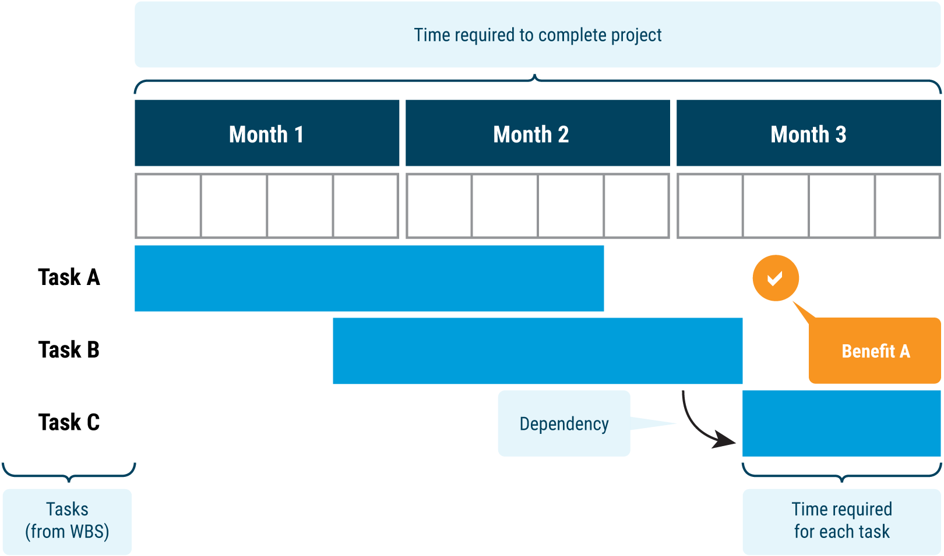

Source: United to Reform

### Baselining performance

1. The Secretary-General has committed to baseline current performance to understand the impact of the reforms; i.e. the difference in performance or capability before and after a change has been implemented is the evidence of either a benefit (if positive) or a dis-benefit (if negative). A baseline is the condition prior to a change being introduced **– but this does not have to be a complicated, technical exercise.** We can baseline using existing performance measures including the relevant parts of your RBM framework, evidence from reviews (audits, evaluations and system wide reviews such as by the JIU), or through a bespoke exercise to understand the current situation.

#### Baselining with mature organisational performance measurement systems

1. Proving reform has had a positive effect on business as usual performance is reliant on mature organisational performance measurement systems being in place and operating effectively. Whenever possible, any potential benefits should be linked to existing sources of evidence; e.g. performance measurement systems, audit and evaluation findings or customer complaints / feedback.

#### Baselining without mature organisational performance measurement systems

1. Oversight bodies have concluded that much of the UN does not have mature performance measurement systems. Consequently, this is an area the Secretary-General’s management reform pillar is focussed on improving. Where existing performance measurement systems are inadequate, project teams need to generate a robust ‘snapshot’ of performance using bespoke methods – a discrete baselining exercise. This has two main advantages:

* Baselines performance as part of the benefits management process; and
* Establishes a method that business as usual teams can use to measure operational performance at appropriate intervals until a more systematic approach is developed.

1. Overall, the business areas you are working with should already understand performance. If not, undertaking a specific exercise to measure current performance could be of interest to them.

#### Techniques to baseline current performance and forecast benefits

1. If required, there are many methodologies which can be applied to baseline performance. For example, many improvement methodologies utilize tools and techniques to establish the ‘current state or As Is’ performance. More system level approaches also consider how to baseline organizational performance, strategic fit and management maturity. Dependent on the reform project, and the type of benefits being pursued, a mix of the following tools and techniques could be appropriate, including:
   * + **Audit & evaluations:** What have independent sources such as audit and evaluations, previous reviews said about performance.

* **Value Stream Analysis / Process mapping:** models the key activities and process metrics including; value vs non-value adding activities, lead time / elapsed time, cost, demand satisfaction, right first time or error rates, user satisfaction et al
* **Information flow mapping:** models the unseen effort of administrative processes. Useful when existing measurement systems are absence.
* **Customer journey mapping:** As per value stream mapping, but from the end user’s perspective. Key when trying to establish an improvement in customer satisfaction.
* **Stakeholder perspectives** – gained through structured or semi-structured interviews, surveys, workshops, Critical Customer Requirements, KANO analysis
* **Observation** – process walk-throughs, time and motion studies.
* **Data analytics** – using existing information sources to develop new performance metrics and predict future performance. To use and draw conclusions from data produced by computer systems, we need to establish the accuracy, completeness and reliability of the system. The results of this assessment could be benefit in itself.
* **Modelling or simulation**: extrapolate current performance and expected benefits from existing data. It will be necessary to establish trends/times series from interviews, data analytics.
* **Benchmarking**: Establishes comparators in different teams, areas or entities with the same operating characteristics. Can be used to establish a comparative base but needs a careful assessment of relevance and feasibility.
* **Pilots**: After test the new way of working and system on a small scale

1. Overall, a key test is if the Benefits Owner believes and signs up to delivering the forecast level of benefits. The key is to ensure all assumptions made during the baselining exercise are documented and tested with staff and end users alike. If there are large areas of uncertainty – this also needs to be noted so any solution can be piloted in a controlled environment before benefits can be forecasted and extrapolated.
2. **NB Bespoke baselining exercises can take time, effort and require specialist skills and expertise. We need to adopt a Pareto approach to planning benefits – i.e. what can be proven using existing sources of information?**

## 3. Track

This chapter contains guidance on tracking benefits during the Project implementation and Continuous improvement phases [Link].

***Key learning:*** There is limited effort required from project teams at this phase of the benefits management cycle - they need to be concentrating on delivering the project. However, it is important that the ‘benefits owner’ keeps a ‘watching brief’ on when benefits may start to occur, or are at risk, in case intervention is required.

### Tracking at project level

1. Project teams should ensure consideration of their benefits realisation plan_Realisation_plan) is part of regular project monitoring activities such as team meetings, status updates. Once benefits milestones have been reached, the benefits owner should ensure the relevant project metrics are periodically monitored to enable realisation activities to be triggered. Key points to note are;

* assigning a member of the team to ensure these activities happen when it makes sense in the context of each individual project.
* The ‘Tracking’ and ‘Realise’ phases of the Benefits Management Cycle often overlap, especially if specific benefits occur before the end of the implementation phase of the project.
* Benefits realisation plan should feature during formal handover from the project team to the business as usual team; and
* Any Continuous Improvement projects must also be included and tracked through the Benefits Realisation Plan by the business as usual team post project-implementation.

### Enabling tracking at portfolio level

1. A second key responsibility of project teams is to ensure that the required details of all benefits statements at project level are entered in the portfolio level Benefits Tracking Register by your entities Benefits Management Focal Point. The UN’s Benefits Tracking Register is a management tool owned by EOSG [See Benefits management at portfolio level]. Any changes at project level to the Benefits Statement need to be reflected in the Benefits Tracking Register. This will be done by the Benefits Management focal point in your organisation.

## 4. Realise

This chapter contains guidance on realising and reporting benefits.

***Key learning:*** Benefits are delivered through making changes, but only realised when the improvements detailed in the benefits statement are proven to have an effect.

The Benefits Owner needs to assure themselves benefits are real before declaring the benefits as realised and reporting this at Portfolio level.

Some benefits may accrue to outside stakeholders - they are equally important and should be tracked and confirmed.

### Realising benefits

1. Once benefits appear to be influencing performance (as per the benefits realisation plan established in the Planning phase), it is important to establish; (a) if there is robust evidence of improvements, and (b) the status of benefits realised vs planned – i.e. how much more improvement is expected. Benefits that will be realised after project implementation should be measured as soon as is practical to gauge performance. The evidence base for this needs to be reconciled with information in the benefits statement, although projects that have an element of business change may need to wait months for new ways of working to become embedded and business as usual.
2. Benefits are dynamic, can be difficult to realise and therefore require active management. For example, many organisations undertake process improvement projects which appear to reduce the amount of staff time involved in completing the process on paper. However, until the actual staff time has been redirected to other priorities there has been no benefit
3. Some benefits may accrue to outside stakeholders. They are equally important and should be tracked and confirmed. For example, better coordination may lead to lower effort for stakeholders engaging with the UN, and greater impact on beneficiaries. The effort of coordinating for UN entities could be the same or even greater – but the benefit to our stakeholders is worth it.

### Assurance over benefits realisation

1. The project Benefits Owner is responsible for reporting benefits have been realised via the Benefits Tracking Register. Prior to this, the Benefits Owner and should assess the quality of the evidence to hand. Evidence should be:

**SUFFICIENT**

* Measurable in quantity and / or convincing in quality
* Able to persuade a reasonable person that conclusions on performance are justified and evidenced

**RELEVANT**

* Linked to the Baseline exercise and the wider benefits statement
* Logical and sensible in relation to project objectives and criteria
* Clearly reflect the purpose, source, and scope of evidence
* Confirmed by end users / key stakeholders

**RELIABLE**

* Consistent with facts but also stands up to a ‘common sense’ test of informed stakeholders
* Corroborated by more than one source
* Direct rather than indirect

1. If the Benefits Owner is relying on existing organisational performance measurement systems and metrics they already use to manage their business area, then they can place assurance on this and report the results. The exception may be if user satisfaction is not routinely measured, and reliant on surveys or similar techniques to augment existing performance metrics. If this is the case, the benefits owner must ensure a suitable exercise is carried out before claiming benefits as realised.
2. If, due to the maturity of performance measurement systems, the Benefits Owner has baselined performance using bespoke techniques when preparing the benefits statement, they need to judge how much of the previous approach should be repeated to establish improved performance. The key here is to be proportionate.

### What if there are dis-benefits

1. We need to be transparent and realistic. Benefits management is a management discipline not propaganda. Most projects will have some type of dis-benefits, whether they are actual negative consequences of change, or a benefit that is perceived as positive by most, but negative by others. Reforms may result in no benefits, dis-benefits, less benefits than originally thought in the benefits statement, or cannot be proven. This does not mean they should be ignored, but we should follow the benefits management process; they should be identified, categorised, quantified and measured in the same way benefits are.
2. Often project teams are reluctant to be forthcoming with dis-benefits. However, dis-benefits are invaluable as they can;
   * generate lessons to help improve next time;
   * provide insight on what your stakeholders perceive as negative consequences, informing communications plans.
   * are an opportunity to trigger and scope continuous improvement activities.

## 5. Confirm

This chapter contains guidance on how the Benefits Owner confirms the benefits of a reform project.

***Key learning:*** Benefits Owners should consider how and when they confirm benefits as realised based on the measures described in their benefits statements or through self-evaluation. From a portfolio perspective, EOSG may also conduct its own assurance activities on a sample basis.

There is inherently a time-lag between initiatives being completed, benefits realised and actual steady-state performance. Continuous improvement activities may lead to even more benefits than predicted. Performance can also degrade when, for example special measures such as surge capacity are removed, or as a result of external or internal events such as a change of staff or mandates from Member States.

### Confirming benefits

1. This is linked to the Benefits Realisation phase [Link]. Benefits are dynamic, may not arise how we thought they would during the planning phase. Benefits Owners need to be confident that they have the evidence that benefits identified are real. Experience suggests that repeating the Baselining approach applied during the planning phase (e.g. performance measurement systems, audit or evaluations, a bespoke exercise) can be a good starting place.

### Confirming benefits to Portfolio level

1. A second key responsibility of the Benefits Owner is to ensure that once benefits are confirmed at project level, they are reported as confirmed in the portfolio level Benefits Tracking Register. This will be performed by the designated Benefits Focal Points. Annex B contains a description of roles and responsibilities.

### Evaluating benefits

1. Benefits owners at Project or Portfolio level may wish to gain assurance on the benefits accrued but also the benefits management approach adopted in a reform to inform continuous learning. The questions below are the basis of a self-evaluation framework.

**Key lines of enquiry:**

* Does the project: have a baseline, know what measurable change it is going to make, and measure it? Are benefits being achieved?
* Has the needs analysis for the programme established the current baseline performance?
* Does the programme have clear objectives that relate to measurable change?
* Are there identified programme benefits and ways of measuring achievement of those objectives?
* Is there an appropriate plan to establish what information needs to be captured to measure future changes in performance?
* Is there a commitment to monitoring the performance to support evaluation of the programme?
* Is there a commitment to review performance against the plan and to determine whether the programme has delivered the intended benefits and outcomes?
* Is the programme on track to deliver intended benefits?

**Essential evidence:**

* Business case including examples of measured / stated benefits
* Benefits documentation complete and up to date; e.g. benefits statement, realisation plan
* Benefits baseline – how compiled.
* Benefits realised – how evidenced
* Benefits ownership – clear and evidenced

# Part 3: Benefits management at portfolio level

This part of the framework describes the different portfolio level enablers required to support an effective benefits management system (**Figure 7**).

***Key learning:*** A benefits management system is built on clear ownership in each entity of the UN undertaking reforms. Each entity must appoint a Benefits Focal Point who is responsible for supporting reform initiatives in their entities can use this approach, and that information reported in the Benefits Tracking Register is accurate and up to date.

The overall objective is embedding a way of working which supports, tracks and enables accurate reporting on progress realising the benefits of the Secretary-General’s reform agenda, including the progress report to the General Assembly in Autumn 2020.

1. 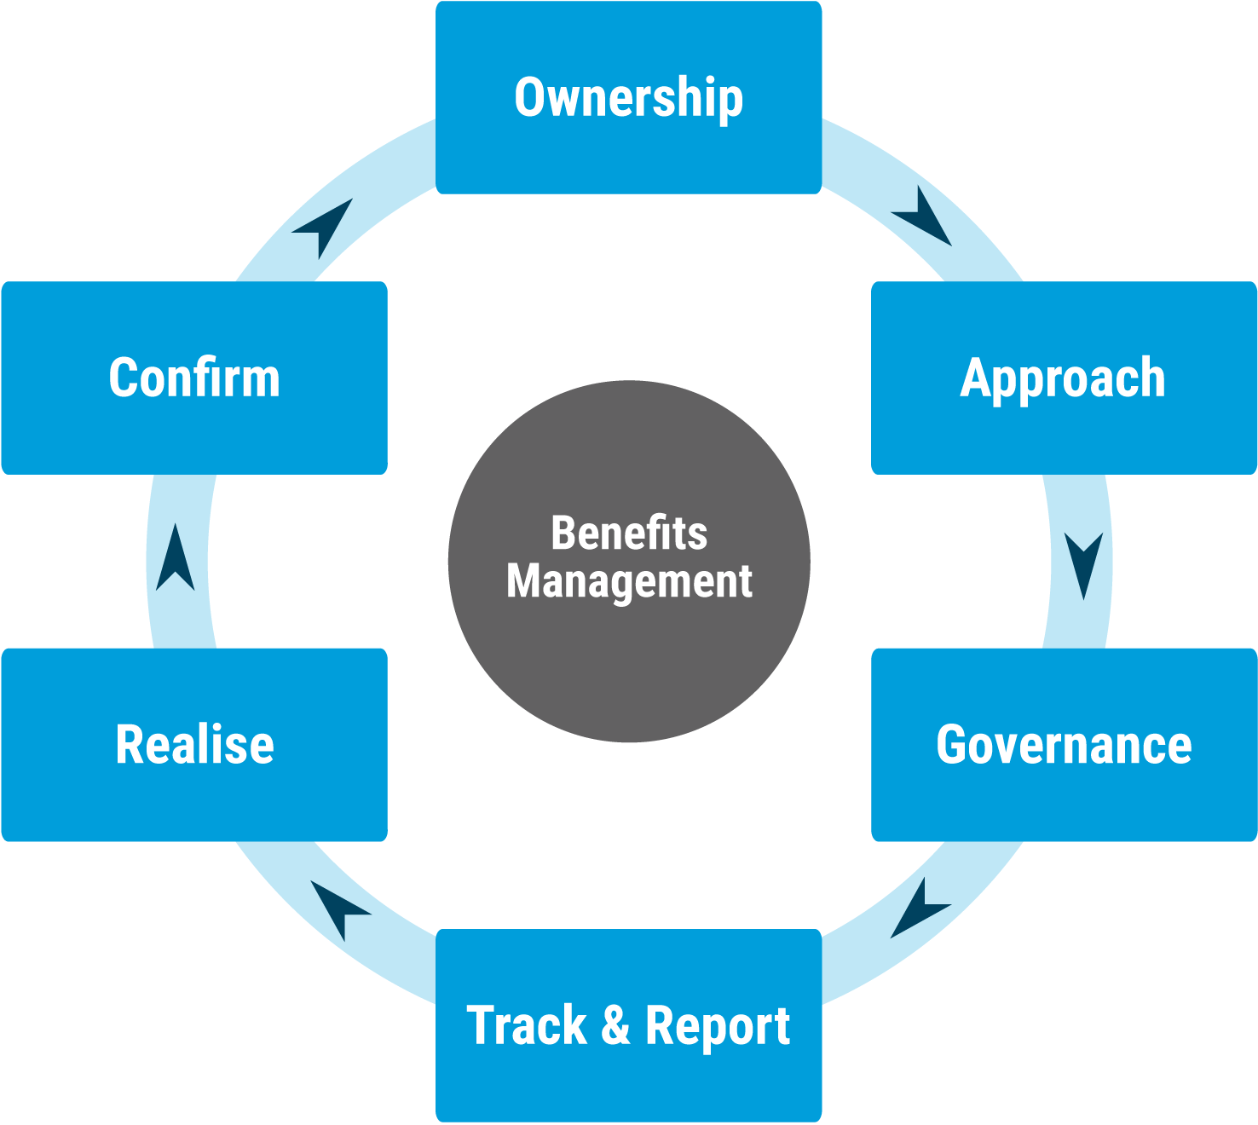The goal is to deliver the commitments contained in the Secretary-General’s reports on the three pillars of reform as approved by the Member States. Those implementing reforms are responsible for planning, delivering and proving benefits. EOSG is responsible for providing a standard approach and key enablers to support this. A description of how the benefits management system will work in practice can be found here [Link]. The individual elements of the Benefits Management system are described below.

Figure 7: The Benefits management enablers at Portfolio level

Includes hyperlinks to the relevant parts of the chapter – hover, hold down ctrl and click. Source: United to Reform

1. Each entity must appoint a Benefits Management Focal Point who will be responsible for:

* Liaising with the EOSG Benefits Management Office
  + - Supporting all reform initiatives to follow the UN’s approach through guidance, training and access to specialist skills and experience when required;
    - Updating the Benefits Tracking Register on a quarterly basis, or when each Benefits Statement has been signed off by the Benefits Owner, or changes have been requested.
    - Tracking benefits at project level in line Benefits realisation plans – following up on expected benefits.
    - Reporting confirmed benefits via the Benefits Tracking Register and any ‘stated benefits’ i.e. case studies, anecdotes which can be reported directly to EOSG BMT via a generic benefits management email address.

## Ownership

1. Benefits ownership needs to be established at each level of the reform. The roles and responsibilities of benefits owners, from the Secretary-General, to Heads of Entities should be stated in each benefits statement, in line with the principle of delegated authority.

## Approach

1. This framework represents the UN’s organisational approach to benefits management. The policy & process owner is the EOSG Benefits Management Team, reporting to Jens Wandel. The framework, guidance, processes and approaches detailed here must be followed by all project teams undertaking UN reform.
2. Some of the techniques contained in this framework, for example in the Baselining section, are not necessarily skills and experience business areas have ‘in-house’. Project teams should inform their respective Benefits Focal point that they require specialist support to, for example, baseline or confirm benefits. The Benefits Focal points can then contact EOSG on this email address who will help coordinate access to the relevant advice, skills and experience. EOSG will also be able to offer training and ad hoc guidance and support to UN entities upon request.

## Governance

1. EOSG Benefits Management Team is responsible for maintaining this framework by continuously improving this framework definitions and principles to address common challenges and user feedback. The goal is to create a consistent benefits management approach across all reform initiatives which will help improve the UN’s maturity in Benefits Management as defined by P3M3 reaches [Annex A]. EOSG will commission a self-evaluation to benchmark the UN’s maturity level in 2020 and another in 2022.
2. The EOSG BMO will ensure regular feedback from the network of Benefits Focal Points on lessons to improve the framework and supporting materials. In addition, the Management Client Board can act as the primary stakeholder forum, channelling formal feedback on the framework, or examples of stated benefits being realised.
3. Each entity is responsible and accountable for ensuring all benefits information is accurate, EOSG BMT will undertake independent information assurance assessments on a sample of benefits, particularly prior to any information being publicly reported. A description of the proposed process can be found in Annex B.

## Track

1. The UN Benefits Tracking Register (BTR) is the primary tool for tracking and reporting the benefits of UN reform initiatives. The BTR is a list of planned benefits from reform initiatives, who is responsible for them, when they are expected to be realised, and how the benefits are measured.
2. The BTR is owned and maintained by EOSG. Any additions or changes required by project teams must be reported and agreed with their relevant Benefits Focal Point for that entity, who will confirm with the Benefits Owner and then update the BTR.
3. **The BTR is a management tool and access to it will be restricted to the Benefits Focal Points. Confirmed benefits, including case studies and stories, will be used by EOSG to report progress to UN stakeholders internally and externally.** A link to the BTR can be found on the [United to Reform website](https://reform.un.org/).
4. The Benefits Tracking Register will include information initially developed in each reform initiative’s benefits statement:
   * + A unique identification number for each initiative so that the expected benefits of each can be tracked throughout the benefits lifecycle
     + The benefits owner
     + The reform objective the benefit is designed to support
     + When the benefit is expected to be realised and by who
     + Baseline and target benefit
     + Current status

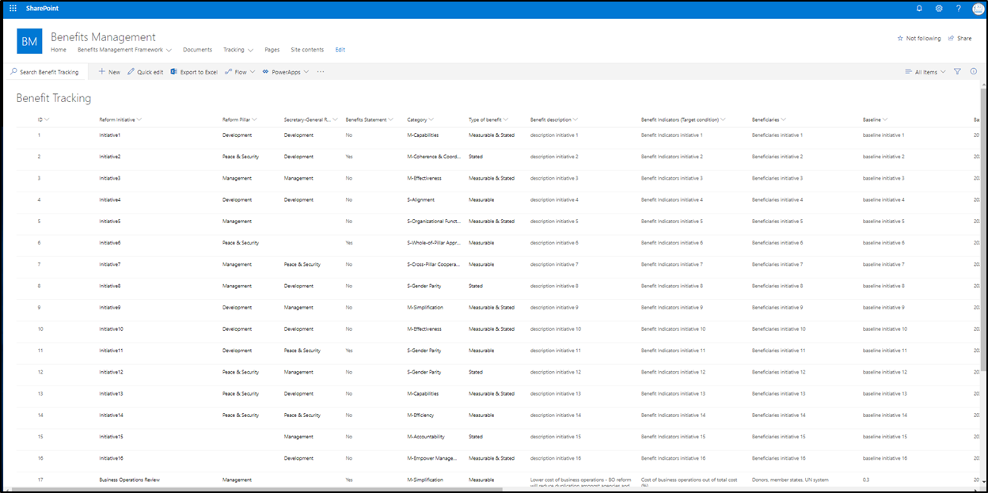

Figure 8 Screenshot of the Benefits Tracking Register

Source: United to Reform

## Realise

1. As benefits are confirmed in each entity, there is the opportunity for Benefits Owners to share lessons, and to apply these solutions across other areas (Continuous improvement). EOSG will also be looking for opportunities to trigger CI interventions across the whole portfolio of reform initiatives.
2. Stated benefits, i.e. beneficiaries who wish to report an improvement in how the UN delivers, should be emailed directly to the EOSG Benefits Management team.

## Confirm

1. As noted above, it is the responsibility of the Benefits Owner as to confirm benefits when they are realised and instruct their designated Benefits Management Focal Point to update the BTR. In addition, EOSG may undertake assurance activity particularly in advance of any public reporting. Confirmed benefits will be used to inform:

* Letters from the Secretary-General to member states
* Stories which will be tweeted and / or published on the United to Reform website
* The Autumn 2020 progress report to member states

## Acknowledgements

This Benefits Management Framework has been developed by Kevin Summersgill on behalf of the Executive Office of the Secretary-General of the United Nations (EOSG), following a pilot exercise delivered by UNLOCK. EOSG own and will continuously improve the manual and the associated Benefits Tracking Register, drawing on the experience of United Nations teams to identify what works well and opportunities to improve.

All United Nations entities are invited to use or adapt this manual to their context.

For comments or questions, please contact EOSG on [eosgbenefitsmanagement@un.org](mailto:eosgbenefitsmanagement@un.org)

## Annex A: Benefits Tracking Process

The example shows how a common process simplification would be tracked. The process owner identifies benefits, Entities implement and realize benefits.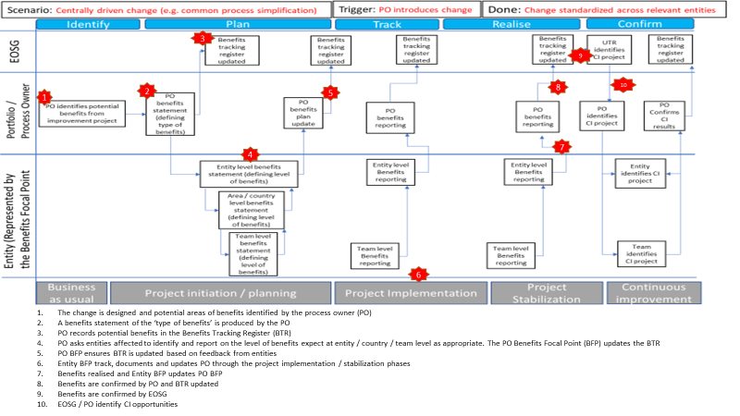

1. Infrastructure and Projects Authority, UK Cabinet Office, *Guide for Effective Benefits Management in Major Projects (2016)*
2. Infrastructure and Projects Authority, UK Cabinet Office, *Guide for Effective Benefits Management in Major Projects (2016)*
3. Steve Jenner, “Managing Benefits”, (APMG International 2012), p.15
4. *Shifting the management paradigm in the United Nations: Implementing a new management architecture for improved effectiveness and strengthened accountability (A/72/492/Add.2) Paragraph 10*
5. SG remarks to UN GA, 27 November 2018.